Certificate of Authenticity

This artwork is a one-of-a kind authentic and original painting.
All copy right and reproduction rights are reserved by the artist:

Alma Al Faham

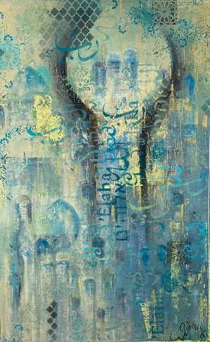

The Divine Within

Oil on Canvas
(30” x 48”) (76cm x 122cm)
Painted in 2020

-----------------------------------------------------------------

www.almafaham.com

The Divine Within

“Don’t judge the way other people connect to God. To each his own way and his own prayer. God does not take us at our word. He looks deep into our hearts. It is not the ceremonies or rituals that make a difference, but whether our hearts are sufficiently pure or not.”
Shams Tabrizi

Religion is an organized system of beliefs and practices, often centered on one or more Gods. There are five major religions in the world: Islam, Christianity, Judaism, Hinduism and Buddhism. These religions have common beliefs and reverence for a natural power or powers, which they regard as a creator and governor of the universe. Each one has its own practices, rules of behavior, values and morals but they all use them to worship the supernatural force…...
In this painting, instead of focusing on the 4,300 religions of the world in a straight forward and typical manner, I chose to dig deep and focus on the core of most religions….worship. The homage paid to ”God.” All my paintings have a concept and a story behind them. In this one I decided to visualize the quote by Shams Tabrizi mentioned above, focus on the spirituality behind all these religions and how we, citizens of the world, should embrace and respect them in order to live in peace and harmony.
The verticality of the painting supports the path towards the sky or the vault of heaven. My style of work is always based on layers and colors of paint. The foundation of the painting is a layer of monuments and buildings of worship places, which all have many things in common like domes, high vaulted buildings and mainly arched stained glass windows. Followed by alternating layers of paint and different techniques revealing the shapes needed from the background. Visually dividing the canvas is an abstract interpretation of two praying hands facing towards the universe, ready to receive the blessings God would pour out on them. The arms melt into the composition all the way to the bottom, leading a track to the top, symbolizing the fact that all religions share the same cores and same logic and their practices lead to the same destiny and goal….The calligraphy used in the three languages of the Abrahamic religions Arabic (the language of the prophet Mohammad peace be upon him and the official language of The United Arab Emirates , Aramaic (the language of Jesus Christ) and Hebrew (the language of prophet Moses) and the word God representing all the deity in all religions. The architectural style of the United Arab Emirates and the ornaments of many mosques are embodied in the Islamic design squares around the painting. The floral vines resemble the designs of the flowers decorating the Sheikh Zayed Grand mosque in Abu Dhabi and Taj Mahal in India as well as many other ornaments in worship places. The mandalas represent Buddhism and Hinduism. In the background and under different lightings, the painting holds many details that I leave to the viewer to explore and discover every time they look at the “The Divine Within.”

Alma Al Faham

